Digital System Design
Student name: Rawan Ali
OU ID: 102769 | LJMU ID: 1142988

TRUTH TABLE:
We plot the truth table using 4 inputs(A-B-C-D) and 7 outputs(a-b-c-d-e-f-g), each letter represents a segment to form the numbers from (0-9) and letters (a-f).
Each row represent a number starting from (0-9) and letters (a-f) each character consist of 7 segments some are off and some are on, to display the number. The turned off segments are represented with a 0 and the turned on segments are represented with 1 to form the character.
INPUTS |  |  |  | OUTPUT
A | B | C | D | a | b | c | d | e | f | g | NUMBER DISPALYED
$$\overline{ A}$$ | $$\overline{B}$$ | $$\overline{C}$$ | $$\overline{D}$$ | 1 | 1 | 1 | 1 | 1 | 1 | 0 | 0
$$\overline{A}$$ | $$\overline{B}$$ | $$\overline{C}$$ | $$D$$ | 0 | 1 | 1 | 0 | 0 | 0 | 0 | 1
$$\overline{A}$$ | $$\overline{B}$$ | $$C$$ | $$\overline{D}$$ | 1 | 1 | 0 | 1 | 1 | 0 | 1 | 2
$$\overline{A}$$ | $$\overline{B}$$ | $$C$$ | $$D$$ | 1 | 1 | 1 | 1 | 0 | 0 | 1 | 3
$$\overline{A}$$ | $$B$$ | $$\overline{C}$$ | $$\overline{D}$$ | 0 | 1 | 1 | 0 | 0 | 1 | 1 | 4
$$\overline{A}$$ | $$B$$ | $$\overline{C}$$ | $$D$$ | 1 | 0 | 1 | 1 | 0 | 1 | 1 | 5
$$\overline{A}$$ | $$B$$ | $$C$$ | $$\overline{D}$$ | 1 | 0 | 1 | 1 | 1 | 1 | 1 | 6
$$\overline{A}$$ | $$B$$ | $$C$$ | $$D$$ | 1 | 1 | 1 | 0 | 0 | 0 | 0 | 7
$$A$$ | $$\overline{B}$$ | $$\overline{C}$$ | $$\overline{D}$$ | 1 | 1 | 1 | 1 | 1 | 1 | 1 | 8
$$A$$ | $$\overline{B}$$ | $$\overline{C}$$ | $$D$$ | 1 | 1 | 1 | 1 | 0 | 1 | 1 | 9
$$A$$ | $$\overline{B}$$ | $$C$$ | $$\overline{D}$$ | 1 | 1 | 1 | 0 | 1 | 1 | 1 | a
$$A$$ | $$\overline{B}$$ | $$C$$ | $$D$$ | 0 | 0 | 1 | 1 | 1 | 1 | 1 | b
$$A$$ | $$B$$ | $$\overline{C}$$ | $$\overline{D}$$ | 0 | 0 | 1 | 1 | 1 | 1 | 1 | c
$$A$$ | $$B$$ | $$\overline{C}$$ | $$D$$ | 0 | 1 | 1 | 1 | 1 | 0 | 1 | d
$$A$$ | $$B$$ | $$C$$ | $$\overline{D}$$ | 1 | 0 | 0 | 1 | 1 | 1 | 1 | e
$$A$$ | $$B$$ | $$C$$ | $$D$$ | 1 | 0 | 0 | 0 | 1 | 1 | 1 | f
Since we have 4 inputs there will be $2^{4}=16$ rows in the truth table.

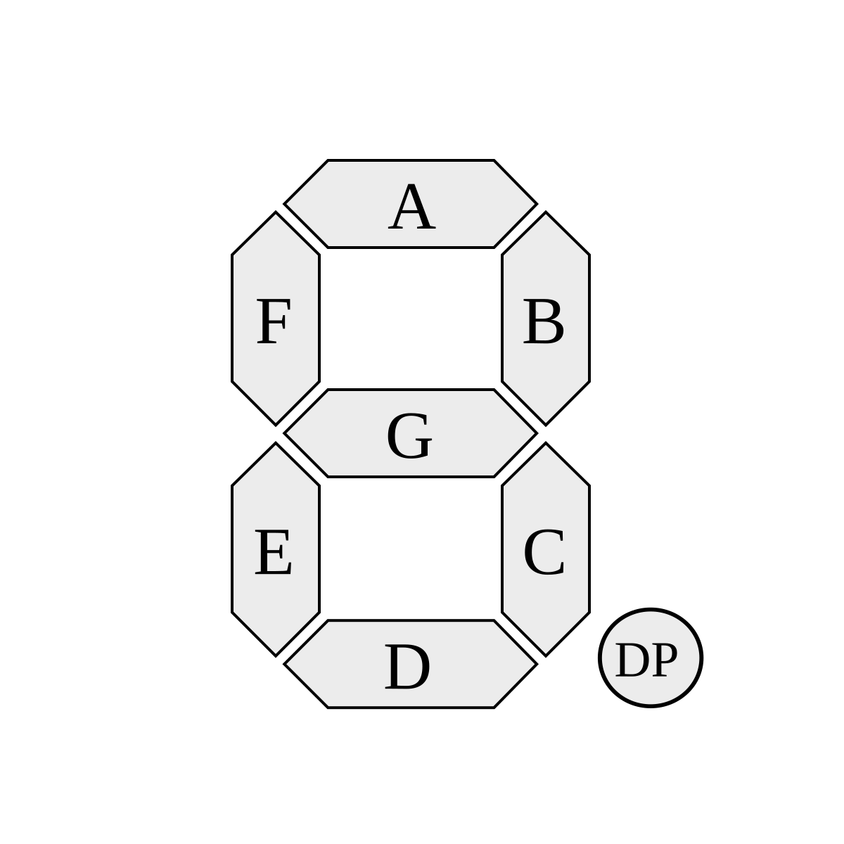

We will not use this part of the truth table because we don’t need it, our Boolean equations will only include the truth tables from (0-9)

BOOLEAN EQUATIONS, CIRCUITS, AND EXTENDED TRUTH TABLES:
Segment (a):
A | B | C | D | a
$$\overline{A}$$ | $$\overline{B}$$ | $$\overline{C}$$ | $$\overline{D}$$ | 1
$$\overline{A}$$ | $$\overline{B}$$ | $$\overline{C}$$ | $$D$$ | 0
$$\overline{A}$$ | $$\overline{B}$$ | $$C$$ | $$\overline{D}$$ | 1
$$\overline{A}$$ | $$\overline{B}$$ | $$C$$ | $$D$$ | 1
$$\overline{A}$$ | $$B$$ | $$\overline{C}$$ | $$\overline{D}$$ | 0
$$\overline{A}$$ | $$B$$ | $$\overline{C}$$ | $$D$$ | 1
$$\overline{A}$$ | $$B$$ | $$C$$ | $$\overline{D}$$ | 1
$$\overline{A}$$ | $$B$$ | $$C$$ | $$D$$ | 1
$$A$$ | $$\overline{B}$$ | $$\overline{C}$$ | $$\overline{D}$$ | 1
$$A$$ | $$\overline{B}$$ | $$\overline{C}$$ | $$D$$ | 1
$a=\overline{\overline{A}.\overline{B}.\overline{C}.D+\overline{A}.B.\overline{C}.\overline{D}}$(apply the inverse of the distribution law AND version)
=$\overline{\overline{A}.C (\overline{B}.D+B.\overline{D})}$ ( De morgan law and involution law)
$=A+C (B+\overline{D})(\overline{B}+D)$ (the distribution law AND version)
$=A+C+B.\overline{B}+B.D+\overline{D}.\overline{B}+\overline{D}.D$ (complement law AND version)
=$A+C+0+B.D+\overline{D}.\overline{B}+0$ (identity law OR version)
$=A+C+B.D+\overline{D}.\overline{B}$
Final equation is: $a=A+C+B.D+\overline{D}.\overline{B}$ 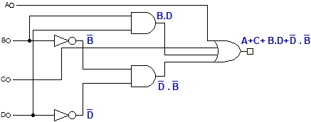

A | B | C | D | $$B.D$$ | $$\overline{B}$$ | $$\overline{D}$$ | $$\overline{D}.\overline{B}$$ | $$A+C+B.D+\overline{D}.\overline{B}$$
$$\overline{A}$$ | $$\overline{B}$$ | $$\overline{C}$$ | $$\overline{D}$$ | 0 | 1 | 1 | 1 | 1
$$\overline{A}$$ | $$\overline{B}$$ | $$\overline{C}$$ | $$D$$ | 0 | 1 | 0 | 0 | 0
$$\overline{A}$$ | $$\overline{B}$$ | $$C$$ | $$\overline{D}$$ | 0 | 1 | 1 | 1 | 1
$$\overline{A}$$ | $$\overline{B}$$ | $$C$$ | $$D$$ | 0 | 1 | 0 | 0 | 1
$$\overline{A}$$ | $$B$$ | $$\overline{C}$$ | $$\overline{D}$$ | 0 | 0 | 1 | 0 | 0
$$\overline{A}$$ | $$B$$ | $$\overline{C}$$ | $$D$$ | 1 | 0 | 0 | 0 | 1
$$\overline{A}$$ | $$B$$ | $$C$$ | $$\overline{D}$$ | 0 | 0 | 1 | 0 | 1
$$\overline{A}$$ | $$B$$ | $$C$$ | $$D$$ | 1 | 0 | 0 | 0 | 1
$$A$$ | $$\overline{B}$$ | $$\overline{C}$$ | $$\overline{D}$$ | 0 | 1 | 1 | 1 | 1
$$A$$ | $$\overline{B}$$ | $$\overline{C}$$ | $$D$$ | 0 | 1 | 0 | 0 | 1
$$A$$ | $$\overline{B}$$ | $$C$$ | $$\overline{D}$$ | 0 | 1 | 1 | 1 | 1
$$A$$ | $$\overline{B}$$ | $$C$$ | $$D$$ | 0 | 1 | 0 | 0 | 1
$$A$$ | $$B$$ | $$\overline{C}$$ | $$\overline{D}$$ | 0 | 0 | 1 | 0 | 1
$$A$$ | $$B$$ | $$\overline{C}$$ | $$D$$ | 1 | 0 | 0 | 0 | 1
$$A$$ | $$B$$ | $$C$$ | $$\overline{D}$$ | 0 | 0 | 1 | 0 | 1
$$A$$ | $$B$$ | $$C$$ | $$D$$ | 1 | 0 | 0 | 0 | 1

Segment (b):
$b=\overline{\overline{A}.B.\overline{C}.D+\overline{A}.B.C.\overline{D}}$ (the inverse of the distribution law AND version)
$=\overline{\overline{A}.B(\overline{C}.D+C.\overline{D})}$ (De morgan law and involution law)
= $A+\overline{B}+(C+\overline{D})(\overline{C}+D)$ (the distribution law AND version)
$=A+\overline{B}+C.\overline{C}+C.D+\overline{D}.\overline{C}+\overline{D}.D$ (complement law AND version)
$=A+\overline{B}+0+C.D+\overline{D}.\overline{C}+0$(identity law OR version)
$=A+\overline{B}+C.D+\overline{D}.\overline{C}$
Final equation is: $b=A+\overline{B}+C.D+\overline{D}.\overline{C}$
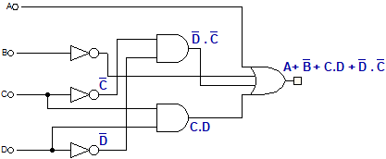

A | B | C | D | b
$$\overline{A}$$ | $$\overline{B}$$ | $$\overline{C}$$ | $$\overline{D}$$ | 1
$$\overline{A}$$ | $$\overline{B}$$ | $$\overline{C}$$ | $$D$$ | 1
$$\overline{A}$$ | $$\overline{B}$$ | $$C$$ | $$\overline{D}$$ | 1
$$\overline{A}$$ | $$\overline{B}$$ | $$C$$ | $$D$$ | 1
$$\overline{A}$$ | $$B$$ | $$\overline{C}$$ | $$\overline{D}$$ | 1
$$\overline{A}$$ | $$B$$ | $$\overline{C}$$ | $$D$$ | 0
$$\overline{A}$$ | $$B$$ | $$C$$ | $$\overline{D}$$ | 0
$$\overline{A}$$ | $$B$$ | $$C$$ | $$D$$ | 1
$$A$$ | $$\overline{B}$$ | $$\overline{C}$$ | $$\overline{D}$$ | 1
$$A$$ | $$\overline{B}$$ | $$\overline{C}$$ | $$D$$ | 1

A | B | C | D | $$\overline{B}$$ | $$\overline{C}$$ | $$\overline{D}$$ | $$C.D$$ | $$\overline{D}.\overline{C}$$ | $$A+\overline{B}+C.D+\overline{D}.\overline{C}$$
$$\overline{A}$$ | $$\overline{B}$$ | $$\overline{C}$$ | $$\overline{D}$$ | 1 | 1 | 1 | $$0$$ | 1 | 1
$$\overline{A}$$ | $$\overline{B}$$ | $$\overline{C}$$ | $$D$$ | 1 | 1 | 0 | 0 | 0 | 1
$$\overline{A}$$ | $$\overline{B}$$ | $$C$$ | $$\overline{D}$$ | 1 | 0 | 1 | 0 | 0 | 1
$$\overline{A}$$ | $$\overline{B}$$ | $$C$$ | $$D$$ | 1 | 0 | 0 | 1 | 0 | 1
$$\overline{A}$$ | $$B$$ | $$\overline{C}$$ | $$\overline{D}$$ | 0 | 1 | 1 | 0 | 1 | 1
$$\overline{A}$$ | $$B$$ | $$\overline{C}$$ | $$D$$ | 0 | 1 | 0 | 0 | 0 | 0
$$\overline{A}$$ | $$B$$ | $$C$$ | $$\overline{D}$$ | 0 | 0 | 1 | 0 | 0 | 0
$$\overline{A}$$ | $$B$$ | $$C$$ | $$D$$ | 0 | 0 | 0 | 1 | 0 | 1
$$A$$ | $$\overline{B}$$ | $$\overline{C}$$ | $$\overline{D}$$ | 1 | 1 | 1 | 0 | 1 | 1
$$A$$ | $$\overline{B}$$ | $$\overline{C}$$ | $$D$$ | 1 | 1 | 0 | 0 | 0 | 1
$$A$$ | $$\overline{B}$$ | $$C$$ | $$\overline{D}$$ | 1 | 0 | 1 | 0 | 0 | 1
$$A$$ | $$\overline{B}$$ | $$C$$ | $$D$$ | 1 | 0 | 0 | 1 | 0 | 1
$$A$$ | $$B$$ | $$\overline{C}$$ | $$\overline{D}$$ | 0 | 1 | 1 | 0 | 1 | 1
$$A$$ | $$B$$ | $$\overline{C}$$ | $$D$$ | 0 | 1 | 0 | 0 | 0 | 1
$$A$$ | $$B$$ | $$C$$ | $$\overline{D}$$ | 0 | 0 | 1 | 0 | 0 | 1
$$A$$ | $$B$$ | $$C$$ | $$D$$ | 0 | 0 | 0 | 1 | 0 | 1

A | B | C | D | c
$$\overline{A}$$ | $$\overline{B}$$ | $$\overline{C}$$ | $$\overline{D}$$ | 1
$$\overline{A}$$ | $$\overline{B}$$ | $$\overline{C}$$ | $$D$$ | 1
$$\overline{A}$$ | $$\overline{B}$$ | $$C$$ | $$\overline{D}$$ | 0
$$\overline{A}$$ | $$\overline{B}$$ | $$C$$ | $$D$$ | 1
$$\overline{A}$$ | $$B$$ | $$\overline{C}$$ | $$\overline{D}$$ | 1
$$\overline{A}$$ | $$B$$ | $$\overline{C}$$ | $$D$$ | 1
$$\overline{A}$$ | $$B$$ | $$C$$ | $$\overline{D}$$ | 1
$$\overline{A}$$ | $$B$$ | $$C$$ | $$D$$ | 1
$$A$$ | $$\overline{B}$$ | $$\overline{C}$$ | $$\overline{D}$$ | 1
$$A$$ | $$\overline{B}$$ | $$\overline{C}$$ | $$D$$ | 1
$c=\overline{\overline{A}.\overline{B}.C.\overline{D}}$ (De morgan law and involution law)
$=A+B+\overline{C}+D$
Final equation is: $c=A+B+\overline{C}+D$
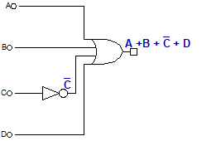

Segment (c):

A | B | C | D | $$\overline{C}$$ | $$A+B+\overline{C}+D$$
$$\overline{A}$$ | $$\overline{B}$$ | $$\overline{C}$$ | $$\overline{D}$$ | 1 | 1
$$\overline{A}$$ | $$\overline{B}$$ | $$\overline{C}$$ | $$D$$ | 1 | 1
$$\overline{A}$$ | $$\overline{B}$$ | $$C$$ | $$\overline{D}$$ | 0 | 0
$$\overline{A}$$ | $$\overline{B}$$ | $$C$$ | $$D$$ | 0 | 1
$$\overline{A}$$ | $$B$$ | $$\overline{C}$$ | $$\overline{D}$$ | 1 | 1
$$\overline{A}$$ | $$B$$ | $$\overline{C}$$ | $$D$$ | 1 | 1
$$\overline{A}$$ | $$B$$ | $$C$$ | $$\overline{D}$$ | 0 | 1
$$\overline{A}$$ | $$B$$ | $$C$$ | $$D$$ | 0 | 1
$$A$$ | $$\overline{B}$$ | $$\overline{C}$$ | $$\overline{D}$$ | 1 | 1
$$A$$ | $$\overline{B}$$ | $$\overline{C}$$ | $$D$$ | 1 | 1
$$A$$ | $$\overline{B}$$ | $$C$$ | $$\overline{D}$$ | 0 | 1
$$A$$ | $$\overline{B}$$ | $$C$$ | $$D$$ | 0 | 1
$$A$$ | $$B$$ | $$\overline{C}$$ | $$\overline{D}$$ | 1 | 1
$$A$$ | $$B$$ | $$\overline{C}$$ | $$D$$ | 1 | 1
$$A$$ | $$B$$ | $$C$$ | $$\overline{D}$$ | 0 | 1
$$A$$ | $$B$$ | $$C$$ | $$D$$ | 0 | 1

A | B | C | D | d
$$\overline{A}$$ | $$\overline{B}$$ | $$\overline{C}$$ | $$\overline{D}$$ | 1
$$\overline{A}$$ | $$\overline{B}$$ | $$\overline{C}$$ | $$D$$ | 0
$$\overline{A}$$ | $$\overline{B}$$ | $$C$$ | $$\overline{D}$$ | 1
$$\overline{A}$$ | $$\overline{B}$$ | $$C$$ | $$D$$ | 1
$$\overline{A}$$ | $$B$$ | $$\overline{C}$$ | $$\overline{D}$$ | 0
$$\overline{A}$$ | $$B$$ | $$\overline{C}$$ | $$D$$ | 1
$$\overline{A}$$ | $$B$$ | $$C$$ | $$\overline{D}$$ | 1
$$\overline{A}$$ | $$B$$ | $$C$$ | $$D$$ | 0
$$A$$ | $$\overline{B}$$ | $$\overline{C}$$ | $$\overline{D}$$ | 1
$$A$$ | $$\overline{B}$$ | $$\overline{C}$$ | $$D$$ | 1
A | B | C | D | $$\overline{B}$$ | $$\overline{C}$$ | $$\overline{D}$$ | $$A+B+C+\overline{D}$$ | $$C.\overline{D}$$ | $$D.\overline{C}$$ | $$(A+\overline{B}+C.\overline{D}+D.\overline{C})$$ | $$\left(A+B+C+\overline{D} \right)$$  $$. (A+\overline{B}+C.\overline{D}+D.\overline{C})$$
$$\overline{A}$$ | $$\overline{B}$$ | $$\overline{C}$$ | $$\overline{D}$$ | 1 | 1 | 1 | 1 | 0 | 0 | 1 | 1
$$\overline{A}$$ | $$\overline{B}$$ | $$\overline{C}$$ | $$D$$ | 1 | 1 | 0 | 0 | 0 | 1 | 1 | 0
$$\overline{A}$$ | $$\overline{B}$$ | $$C$$ | $$\overline{D}$$ | 1 | 0 | 1 | 1 | 1 | 0 | 1 | 1
$$\overline{A}$$ | $$\overline{B}$$ | $$C$$ | $$D$$ | 1 | 0 | 0 | 1 | 0 | 0 | 1 | 1
$$\overline{A}$$ | $$B$$ | $$\overline{C}$$ | $$\overline{D}$$ | 0 | 1 | 1 | 1 | 0 | 0 | 0 | 0
$$\overline{A}$$ | $$B$$ | $$\overline{C}$$ | $$D$$ | 0 | 1 | 0 | 1 | 0 | 1 | 1 | 1
$$\overline{A}$$ | $$B$$ | $$C$$ | $$\overline{D}$$ | 0 | 0 | 1 | 1 | 1 | 0 | 1 | 1
$$\overline{A}$$ | $$B$$ | $$C$$ | $$D$$ | 0 | 0 | 0 | 1 | 0 | 0 | 0 | 0
$$A$$ | $$\overline{B}$$ | $$\overline{C}$$ | $$\overline{D}$$ | 1 | 1 | 1 | 1 | 0 | 0 | 1 | 1
$$A$$ | $$\overline{B}$$ | $$\overline{C}$$ | $$D$$ | 1 | 1 | 0 | 1 | 0 | 1 | 1 | 1
$$A$$ | $$\overline{B}$$ | $$C$$ | $$\overline{D}$$ | 1 | 0 | 1 | 1 | 1 | 0 | 1 | 1
$$A$$ | $$\overline{B}$$ | $$C$$ | $$D$$ | 1 | 0 | 0 | 1 | 0 | 0 | 1 | 1
$$A$$ | $$B$$ | $$\overline{C}$$ | $$\overline{D}$$ | 0 | 1 | 1 | 1 | 0 | 0 | 1 | 1
$$A$$ | $$B$$ | $$\overline{C}$$ | $$D$$ | 0 | 1 | 0 | 1 | 0 | 1 | 1 | 1
$$A$$ | $$B$$ | $$C$$ | $$\overline{D}$$ | 0 | 0 | 1 | 1 | 1 | 0 | 1 | 1
$$A$$ | $$B$$ | $$C$$ | $$D$$ | 0 | 0 | 0 | 1 | 0 | 1 | 1 | 1
$d=\overline{\overline{A}.\overline{B}.\overline{C}.D+\overline{A}.B.\overline{C}.\overline{D}+\overline{A}.B.C.D}$ (the inverse of the distribution law AND version)
=$\overline{\overline{A}.\overline{B}.\overline{C}.D+\overline{A}.B\left(\overline{C}.\overline{D}+C.D\right)}$ (De morgan law and involution law)
$=(A+B+C+\overline{D}) . ( A+\overline{B}+(C+D)(\overline{C}+\overline{D})$) (the distribution law AND version)
$=\left(A+B+C+\overline{D}\right) . ( A+\overline{B}+C\overline{C}+C\overline{D}+D\overline{C}+D\overline{D})$ (complement law AND version)
$=\left(A+B+C+\overline{D}\right) . (A+\overline{B}+0+C.\overline{D}+D.\overline{C}+0)$ (identity law OR version)
$=\left(A+B+C+\overline{D}\right) . ( A+\overline{B}+C.\overline{D}+D.\overline{C})$
Final equation is: $d=\left(A+B+C+\overline{D} \right) . (A+\overline{B}+C.\overline{D}+D.\overline{C})$
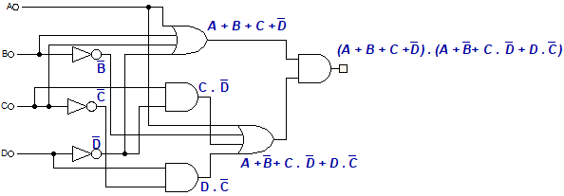

Segment (d):
A | B | C | D | e
$$\overline{A}$$ | $$\overline{B}$$ | $$\overline{C}$$ | $$\overline{D}$$ | 1
$$\overline{A}$$ | $$\overline{B}$$ | $$\overline{C}$$ | $$D$$ | 0
$$\overline{A}$$ | $$\overline{B}$$ | $$C$$ | $$\overline{D}$$ | 1
$$\overline{A}$$ | $$\overline{B}$$ | $$C$$ | $$D$$ | 0
$$\overline{A}$$ | $$B$$ | $$\overline{C}$$ | $$\overline{D}$$ | 0
$$\overline{A}$$ | $$B$$ | $$\overline{C}$$ | $$D$$ | 0
$$\overline{A}$$ | $$B$$ | $$C$$ | $$\overline{D}$$ | 1
$$\overline{A}$$ | $$B$$ | $$C$$ | $$D$$ | 0
$$A$$ | $$\overline{B}$$ | $$\overline{C}$$ | $$\overline{D}$$ | 1
$$A$$ | $$\overline{B}$$ | $$\overline{C}$$ | $$D$$ | 0
$e=\overline{A}.\overline{B}.\overline{C}.\overline{D}+\overline{A}.\overline{B}.C.\overline{D}+\overline{A}.B.C.\overline{D}+A.\overline{B}.\overline{C}.\overline{D}$ (The inverse of the distribution law
AND version)
$=\overline{B}.\overline{C}.\overline{D}\left(\overline{A}+A\right)+\overline{A}.C.\overline{D}(\overline{B}+B)$ (the complement law)
$=\overline{B}.\overline{C}.\overline{D}\left(1\right)+\overline{A}.C.\overline{D}\left(1\right)$ (identity law AND version)
$$=\left(\overline{B}.\overline{C}.\overline{D}\right)+(\overline{A}.C.\overline{D})$$
Final equation is: $e=\left(\overline{B}.\overline{C}.\overline{D}\right)+(\overline{A}.C.\overline{D})$
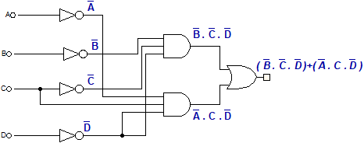

Segment (e):

A | B | C | D | $$\overline{A}$$ | $$\overline{B}$$ | $$\overline{C}$$ | $$\overline{D}$$ | $$\left(\overline{B}.\overline{C}.\overline{D}\right)$$ | $$\overline{A}.C.\overline{D}$$ | $$\left(\overline{B}.\overline{C}.\overline{D}\right)+(\overline{A}.C.\overline{D})$$
$$\overline{A}$$ | $$\overline{B}$$ | $$\overline{C}$$ | $$\overline{D}$$ | 1 | 1 | 1 | 1 | 1 | 0 | 1
$$\overline{A}$$ | $$\overline{B}$$ | $$\overline{C}$$ | $$D$$ | 1 | 1 | 1 | 0 | 0 | 0 | 0
$$\overline{A}$$ | $$\overline{B}$$ | $$C$$ | $$\overline{D}$$ | 1 | 1 | 0 | 1 | 0 | 1 | 1
$$\overline{A}$$ | $$\overline{B}$$ | $$C$$ | $$D$$ | 1 | 1 | 0 | 0 | 0 | 0 | 0
$$\overline{A}$$ | $$B$$ | $$\overline{C}$$ | $$\overline{D}$$ | 1 | 0 | 1 | 1 | 0 | 0 | 0
$$\overline{A}$$ | $$B$$ | $$\overline{C}$$ | $$D$$ | 1 | 0 | 1 | 0 | 0 | 0 | 0
$$\overline{A}$$ | $$B$$ | $$C$$ | $$\overline{D}$$ | 1 | 0 | 0 | 1 | 0 | 1 | 1
$$\overline{A}$$ | $$B$$ | $$C$$ | $$D$$ | 1 | 0 | 0 | 0 | 0 | 0 | 0
$$A$$ | $$\overline{B}$$ | $$\overline{C}$$ | $$\overline{D}$$ | 0 | 1 | 1 | 1 | 1 | 0 | 1
$$A$$ | $$\overline{B}$$ | $$\overline{C}$$ | $$D$$ | 0 | 1 | 1 | 0 | 0 | 0 | 0
$$A$$ | $$\overline{B}$$ | $$C$$ | $$\overline{D}$$ | 0 | 1 | 0 | 1 | 0 | 0 | 0
$$A$$ | $$\overline{B}$$ | $$C$$ | $$D$$ | 0 | 1 | 0 | 0 | 0 | 0 | 0
$$A$$ | $$B$$ | $$\overline{C}$$ | $$\overline{D}$$ | 0 | 0 | 1 | 1 | 0 | 0 | 0
$$A$$ | $$B$$ | $$\overline{C}$$ | $$D$$ | 0 | 0 | 1 | 0 | 0 | 0 | 0
$$A$$ | $$B$$ | $$C$$ | $$\overline{D}$$ | 0 | 0 | 0 | 1 | 0 | 0 | 0
$$A$$ | $$B$$ | $$C$$ | $$D$$ | 0 | 0 | 0 | 0 | 0 | 0 | 0

A | B | C | D | f
$$\overline{A}$$ | $$\overline{B}$$ | $$\overline{C}$$ | $$\overline{D}$$ | 1
$$\overline{A}$$ | $$\overline{B}$$ | $$\overline{C}$$ | $$D$$ | 0
$$\overline{A}$$ | $$\overline{B}$$ | $$C$$ | $$\overline{D}$$ | 0
$$\overline{A}$$ | $$\overline{B}$$ | $$C$$ | $$D$$ | 0
$$\overline{A}$$ | $$B$$ | $$\overline{C}$$ | $$\overline{D}$$ | 1
$$\overline{A}$$ | $$B$$ | $$\overline{C}$$ | $$D$$ | 1
$$\overline{A}$$ | $$B$$ | $$C$$ | $$\overline{D}$$ | 1
$$\overline{A}$$ | $$B$$ | $$C$$ | $$D$$ | 0
$$A$$ | $$\overline{B}$$ | $$\overline{C}$$ | $$\overline{D}$$ | 1
$$A$$ | $$\overline{B}$$ | $$\overline{C}$$ | $$D$$ | 1
$f=\overline{\overline{A}.\overline{B}.\overline{C}.D+\overline{A}.\overline{B}.C.\overline{D}+\overline{A}.\overline{B}.C.D+\overline{A}.B.C.D}$(the inverse of the distribution law AND version)
$=\overline{\overline{A}\left(\overline{B}.\overline{C}.D+\overline{A}.\overline{B}.C.\overline{D}+\overline{A}.\overline{B}.C.D+\overline{A}.B.C.D\right)}$ (De morgan law and involution law)
$=A+\overline{\overline{B}.\overline{C}.D+\overline{B}.C.\overline{D}+\overline{B}.C.D+B.C.D}$ (the inverse of the distribution law AND version)
$=A+\overline{\overline{B}(\overline{C}.D+C.\overline{D}+C.D)+B.C.D}$ (the inverse of the distribution law AND version)
$=A+\overline{\overline{B}(\overline{C}.D+C(\overline{D}+D)+B.C.D}$(the complement law)
$=A+\overline{\overline{B}(\overline{C}.D+C(1)+B.C.D}$ (identity law AND version)
$=A+\overline{\overline{B}(\overline{C}.D+C)+B.C.D}$ (The distribution law OR version)
$=A+\overline{\overline{B}\left(\left(C+\overline{C}\right)\left(C+D\right)\right)+B.C.D}$ (the complement law)
$= A+\overline{\overline{B}\left(\left(1\right)\left(C+D\right)\right)+B.C.D}$ (identity law AND version)
$= A+\overline{\overline{B}\left(C+D\right)+B.C.D}$ (Distribution law AND version)
$= A+\overline{\overline{B}.C+\overline{B.}D+B.C.D}$ (De morgan law and involution law)
$=A+(B+\overline{C})(B+\overline{D})(\overline{B}+\overline{C}+\overline{D})$ (the inverse of the distribution law OR version)
$=A+\left(B+\overline{C}\overline{D}\right)\left(\overline{B}+\overline{C}+\overline{D}\right)$ (Multiply both brackets)
$=A+B\left(\overline{B}+\overline{C}+\overline{D}\right)+\overline{C}\overline{D}\left(\overline{B}+\overline{C}+\overline{D}\right)$ (Distribution law AND version)
$=A+B.\overline{B}+B.\overline{C}+B.\overline{D}+\overline{C}.\overline{D}.\overline{ B}+ \overline{C}.\overline{C}.\overline{D}+\overline{D}.\overline{D}. \overline{C}$ (idempotent law AND version)
(complement law)
$=A+0+B.\overline{C}+B.\overline{D}+\overline{C}.\overline{D}.\overline{ B}+ \overline{C}.\overline{D}+\overline{D}. \overline{C}$ (identity law)
$=A+B.\overline{C}+B.\overline{D}+\overline{C}.\overline{D}.\overline{ B}+ \overline{C}.\overline{D}$ (Absorption law)
$=A+B.\overline{C}+B.\overline{D}+ \overline{C}.\overline{D}$
Final equation is: $f=A+B.\overline{C}+B.\overline{D}+ \overline{C}.\overline{D}$

Segment (f):

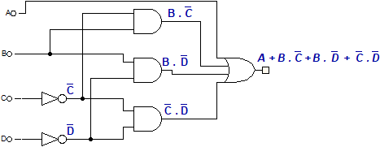
A | B | C | D | $$\overline{A}$$ | $$\overline{B}$$ | $$\overline{C}$$ | $$\overline{D}$$ | $$B.\overline{C}$$ | $$B.\overline{D}$$ | $$\overline{C}.\overline{D}$$ | $$A+B.\overline{C}+B.\overline{D}+ \overline{C}.\overline{D}$$
$$\overline{A}$$ | $$\overline{B}$$ | $$\overline{C}$$ | $$\overline{D}$$ | 1 | 1 | 1 | 1 | 0 | 0 | 1 | 1
$$\overline{A}$$ | $$\overline{B}$$ | $$\overline{C}$$ | $$D$$ | 1 | 1 | 1 | 0 | 0 | 0 | 0 | 0
$$\overline{A}$$ | $$\overline{B}$$ | $$C$$ | $$\overline{D}$$ | 1 | 1 | 0 | 1 | 0 | 0 | 0 | 0
$$\overline{A}$$ | $$\overline{B}$$ | $$C$$ | $$D$$ | 1 | 1 | 0 | 0 | 0 | 0 | 0 | 0
$$\overline{A}$$ | $$B$$ | $$\overline{C}$$ | $$\overline{D}$$ | 1 | 0 | 1 | 1 | 1 | 1 | 1 | 1
$$\overline{A}$$ | $$B$$ | $$\overline{C}$$ | $$D$$ | 1 | 0 | 1 | 0 | 1 | 0 | 0 | 1
$$\overline{A}$$ | $$B$$ | $$C$$ | $$\overline{D}$$ | 1 | 0 | 0 | 1 | 0 | 1 | 0 | 1
$$\overline{A}$$ | $$B$$ | $$C$$ | $$D$$ | 1 | 0 | 0 | 0 | 0 | 0 | 0 | 0
$$A$$ | $$\overline{B}$$ | $$\overline{C}$$ | $$\overline{D}$$ | 0 | 1 | 1 | 1 | 0 | 0 | 1 | 1
$$A$$ | $$\overline{B}$$ | $$\overline{C}$$ | $$D$$ | 0 | 1 | 1 | 0 | 0 | 0 | 0 | 1
$$A$$ | $$\overline{B}$$ | $$C$$ | $$\overline{D}$$ | 0 | 1 | 0 | 1 | 0 | 0 | 0 | 1
$$A$$ | $$\overline{B}$$ | $$C$$ | $$D$$ | 0 | 1 | 0 | 0 | 0 | 0 | 0 | 1
$$A$$ | $$B$$ | $$\overline{C}$$ | $$\overline{D}$$ | 0 | 0 | 1 | 1 | 1 | 1 | 1 | 1
$$A$$ | $$B$$ | $$\overline{C}$$ | $$D$$ | 0 | 0 | 1 | 0 | 1 | 0 | 0 | 1
$$A$$ | $$B$$ | $$C$$ | $$\overline{D}$$ | 0 | 0 | 0 | 1 | 0 | 1 | 0 | 1
$$A$$ | $$B$$ | $$C$$ | $$D$$ | 0 | 0 | 0 | 0 | 0 | 0 | 0 | 1

Segment (g):
A | B | C | D | g
$$\overline{A}$$ | $$\overline{B}$$ | $$\overline{C}$$ | $$\overline{D}$$ | 0
$$\overline{A}$$ | $$\overline{B}$$ | $$\overline{C}$$ | $$D$$ | 0
$$\overline{A}$$ | $$\overline{B}$$ | $$C$$ | $$\overline{D}$$ | 1
$$\overline{A}$$ | $$\overline{B}$$ | $$C$$ | $$D$$ | 1
$$\overline{A}$$ | $$B$$ | $$\overline{C}$$ | $$\overline{D}$$ | 1
$$\overline{A}$$ | $$B$$ | $$\overline{C}$$ | $$D$$ | 1
$$\overline{A}$$ | $$B$$ | $$C$$ | $$\overline{D}$$ | 1
$$\overline{A}$$ | $$B$$ | $$C$$ | $$D$$ | 0
$$A$$ | $$\overline{B}$$ | $$\overline{C}$$ | $$\overline{D}$$ | 1
$$A$$ | $$\overline{B}$$ | $$\overline{C}$$ | $$D$$ | 1
$g=\overline{\overline{A}.\overline{B}.\overline{C}.\overline{D}+\overline{A}.\overline{B}.\overline{C}.D+\overline{A}.B.C.D}$ (the inverse of the distribution law AND version)
$=\overline{\overline{A}.\overline{B}.\overline{C}(\overline{D}+D)+\overline{A}.B.C.D}$ (the complement law OR version)
$= \overline{\overline{A}.\overline{B}.\overline{C}(1)+\overline{A}.B.C.D}$ (identity law AND version)
$=\overline{\overline{A}.\overline{B}.\overline{C}+\overline{A}.B.C.D}$ (De morgan law and involution law)
$=A+B+C . A+\overline{B}+\overline{C}+\overline{D}$
Final equation is: $g=(A+B+C) . ( A+\overline{B}+\overline{C}+\overline{D})$
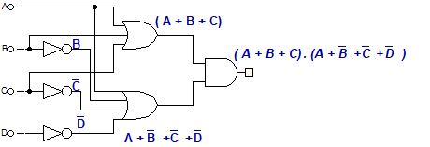

A | B | C | D | $$\overline{B}$$ | $$\overline{C}$$ | $$\overline{D}$$ | $$A+B+C$$ | $$A+\overline{B}+\overline{C}+\overline{D}$$ | $$\left(A+B+C\right)$$  $.( A+\overline{B}+\overline{C}+\overline{D}$)
$$\overline{A}$$ | $$\overline{B}$$ | $$\overline{C}$$ | $$\overline{D}$$ | 1 | 1 | 1 | 0 | 1 | 0
$$\overline{A}$$ | $$\overline{B}$$ | $$\overline{C}$$ | $$D$$ | 1 | 1 | 0 | 0 | 1 | 0
$$\overline{A}$$ | $$\overline{B}$$ | $$C$$ | $$\overline{D}$$ | 1 | 0 | 1 | 1 | 1 | 1
$$\overline{A}$$ | $$\overline{B}$$ | $$C$$ | $$D$$ | 1 | 0 | 0 | 1 | 1 | 1
$$\overline{A}$$ | $$B$$ | $$\overline{C}$$ | $$\overline{D}$$ | 0 | 1 | 1 | 1 | 1 | 1
$$\overline{A}$$ | $$B$$ | $$\overline{C}$$ | $$D$$ | 0 | 1 | 0 | 1 | 1 | 1
$$\overline{A}$$ | $$B$$ | $$C$$ | $$\overline{D}$$ | 0 | 0 | 1 | 1 | 1 | 1
$$\overline{A}$$ | $$B$$ | $$C$$ | $$D$$ | 0 | 0 | 0 | 1 | 0 | 0
$$A$$ | $$\overline{B}$$ | $$\overline{C}$$ | $$\overline{D}$$ | 1 | 1 | 1 | 1 | 1 | 1
$$A$$ | $$\overline{B}$$ | $$\overline{C}$$ | $$D$$ | 1 | 1 | 0 | 1 | 1 | 1
$$A$$ | $$\overline{B}$$ | $$C$$ | $$\overline{D}$$ | 1 | 0 | 1 | 1 | 1 | 1
$$A$$ | $$\overline{B}$$ | $$C$$ | $$D$$ | 1 | 0 | 0 | 1 | 1 | 1
$$A$$ | $$B$$ | $$\overline{C}$$ | $$\overline{D}$$ | 0 | 1 | 1 | 1 | 1 | 1
$$A$$ | $$B$$ | $$\overline{C}$$ | $$D$$ | 0 | 1 | 0 | 1 | 1 | 1
$$A$$ | $$B$$ | $$C$$ | $$\overline{D}$$ | 0 | 0 | 1 | 1 | 1 | 1
$$A$$ | $$B$$ | $$C$$ | $$D$$ | 0 | 0 | 0 | 1 | 1 | 1

THE SEQUENCES:
We use the sequences to view all our 10 numbers (2025102769) in order after each other.
To plot our sequences, we take the value of the inputs (A-B-C-D) for each number.
 | 2 | 0 | 2 | 5 | 1 | 0 | 2 | 7 | 6 | 9
A | 0 | 0 | 0 | 0 | 0 | 0 | 0 | 0 | 0 | 1
B | 0 | 0 | 0 | 1 | 0 | 0 | 0 | 1 | 1 | 0
C | 1 | 0 | 1 | 0 | 0 | 0 | 1 | 1 | 1 | 0
D | 0 | 0 | 0 | 1 | 1 | 0 | 0 | 1 | 0 | 1

- Sequence for A: 0000000001
- Sequence for B: 0001000110
- Sequence for C: 1010001110
- Sequence for D: 000110010

-Those are the inputs, each one from (A-B-C-D) contains the sequence that we plotted previously
FINAL CIRCUIT:
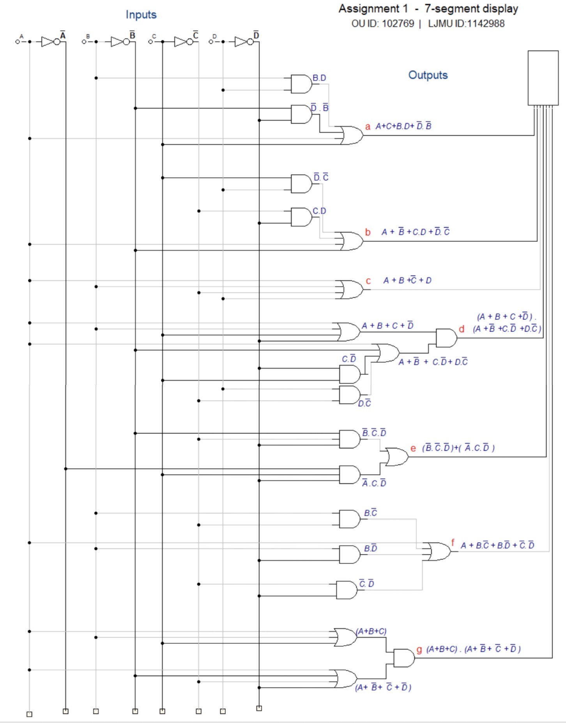
-The 7-segment display
-Each letter in red represents the output of that circuit, and the segment it is connected to

-connect all the circuits we made together

THE NUMBERS DISPLAYED IN ORDER WILL BE:

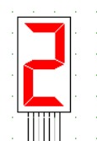
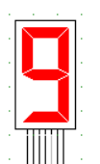
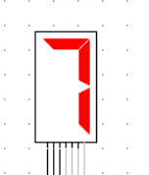
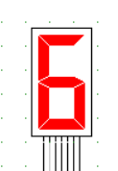

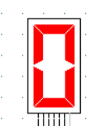
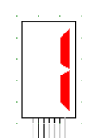
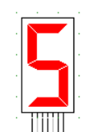
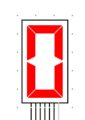

CONCLUSION:

